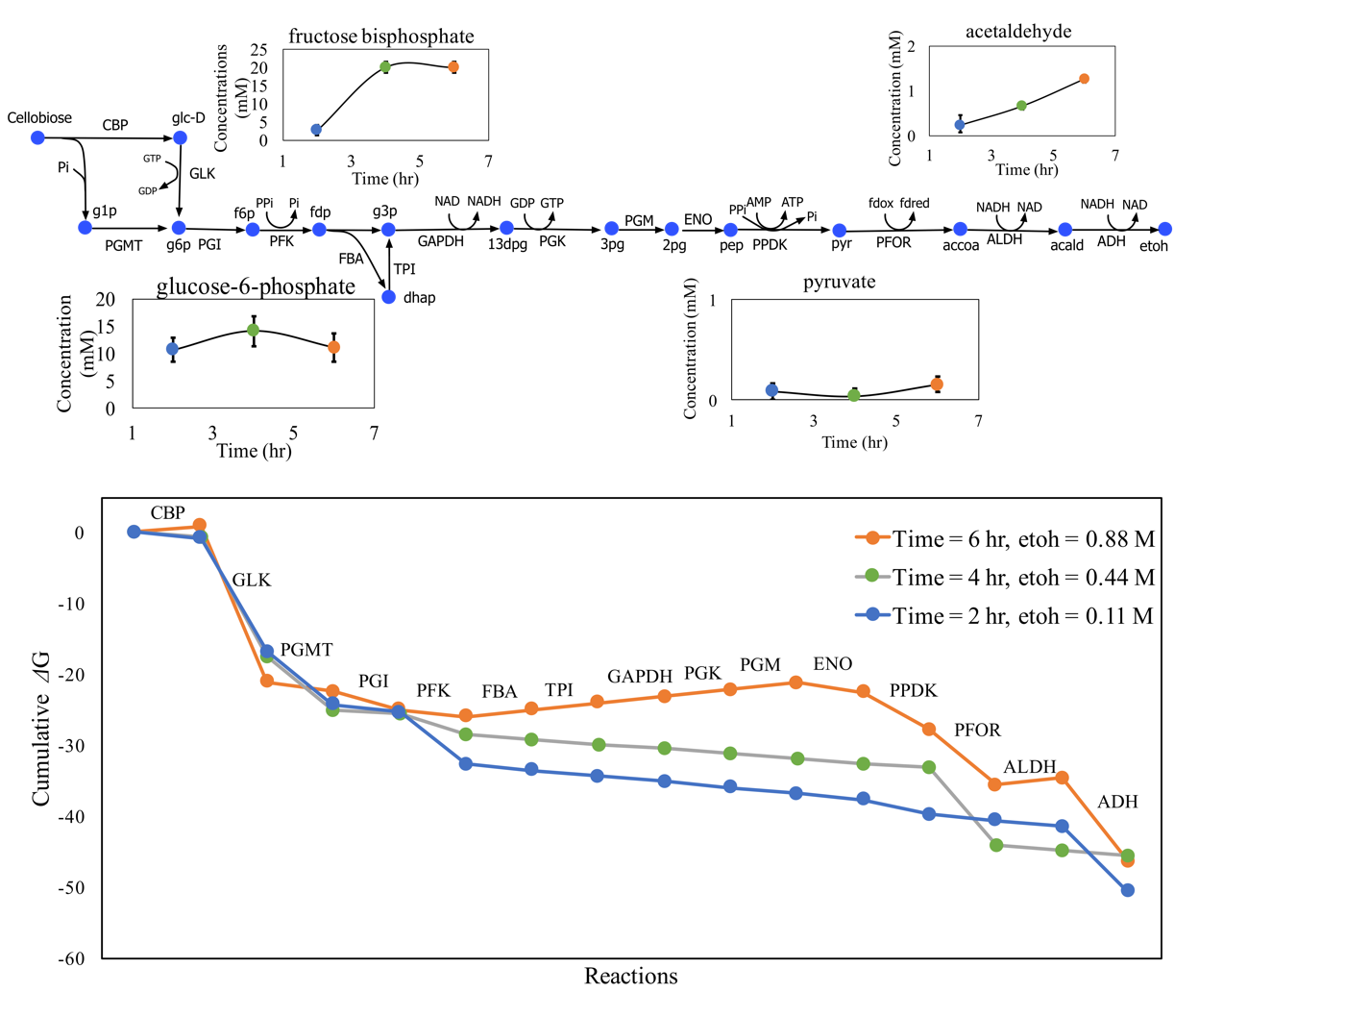

**Figure S1**:Reanalyzing Glycolysis with ethanol production pathway in wild-type C. thermocellum with PPDK showing the thermodynamic analysis predicted variation in metabolite concentrations of key metabolites across time points using values from both the datasets in Tian et al. The infeasibility in the final time point is exaggerated because of the increase in NADH/NAD values adds to GAPDH infeasibility. However, the overall trend of changes in metabolite pools of upper glycolysis metabolites remains similar. The external ethanol concentration increases along the time points. The bottom panel shows the thermodynamic profile of the ethanol production pathway for the three different time points shown as change in Gibbs free energy of the reactions. The thermodynamic infeasibility for the final time point is a consequence of the positive slope of CBP, FBA, TPI, GAPDH, PGK, PGM, and ALDH reactions.